**Key Features**

• Gen4 steps up to the arena with more than 55% improvement in random performance compared to 980 PRO.  
  
• With read and write speeds up to 7450/6900 MB/s², you’ll reach near max performance of PCIe® 4.0³ powering through for any use.  
  
• Give yourself some space with storage capacities from 1TB to 4TB.  
  
• The ultra-slim Integrated Heatsink dissipates heat from your device for uninterrupted play.

Model

**990 PRO**

$119.99~~$159.99- original price~~

**Save $40.00**

**990 PRO with Heatsink**

$289.99~~$479.99- original price~~

**Save $190.00**

Storage

**4TB**

$289.99- Current Price~~$479.99- original price~~

**Save $190.00**

**2TB**

$169.99- Current Price~~$264.99- original price~~

**Save $95.00**

**1TB**

$109.99- Current Price~~$174.99- original price~~

**Save $65.00**

**VIP Advantage**

**VIP Advantage membershipLearn more**

* 2 Year Samsung Care+ (without Theft and Loss)
* Exclusive Discounts & Early Access

To select this option, please sign in or create a Samsung account

**Premium Benefits**

**$149.99/yr**

**Delivery & professional services**

Availability for:

96928

Delivery

**Delivery**

Not available



**In-Store Pickup**

Not available

This product is currently not available in your area.

**Choose your purchase option**

Questions? Ask a Financing Expert

**One-time Payment**

**$289.99**

**Samsung Financing**(Pay Monthly)

**$24.16/mo**

for**12 mos ⊕σ**

**Pay in 4 Installments**

**$72.50**

**every two weeks σπ**

**One-time payment**

Pay with your credit card, debit card or a pay app. Excludes taxes and shipping.

**990 PRO w/ Heatsink PCIe® 4.0 NVMe™ SSD 4TB$289.99**

**Total**

**$289.99~~$479.99- original price~~**

**You Saved Today$190.00**



**Log in now to earn up to 1.5% back in Samsung Rewards Points**

**Add to cart**

[**Where to buy**](https://www.samsung.com/us/computing/memory-storage/solid-state-drives/990-pro-w-heatsink-pcie-4-0-nvme-ssd-4tb-mz-v9p4t0cw-buy)

Supported payment types:

Credit CardPayPal Venmo Checkoutamazonpaygooglepay

**Blazing speed. Cool victory.**

Consider this a cheat code. Our Samsung 990 PRO Gen4 with Heatsink SSD helps you reach near max performance² with lightning-fast speeds and Heatsink for improved temperature control.

*²2 PCIe 4.0’s best theoretical sequential read is 8000 MB/s - 990 PRO reaches 7450 MB/s as of Q3, 2022.*



**Reach the next level**

Gen4 M.2 Internal Solid State Drive with Heatsink

Got a need for speed? Gen4 steps up to the arena with faster transfer speeds and high-performance bandwidth—all while keeping things cool. With a more than 55% improvement in random performance compared to 980 PRO, it’s fully here for heavy computing and faster loading.

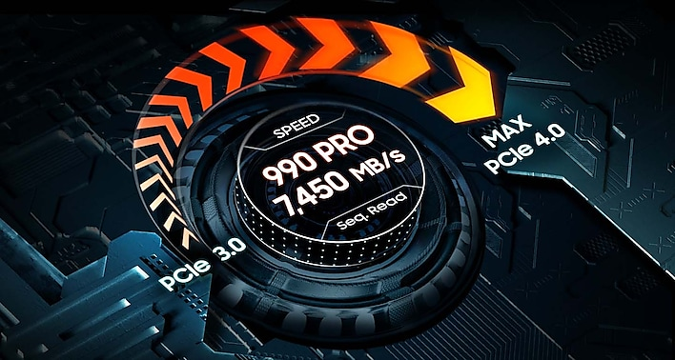

**The fastest SSD from the world's #1 flash memory brand¹**

Read/Write Speeds up to 7,450/6,900 MB/s

The speed you need for any occasion. And with read and write speeds up to 7450/6900 MB/s² you’ll reach near max performance of PCIe® 4.0³ powering through for any use. Our fastest data-transfer speeds dare to zoom past the finish line for the ultimate experience.

*¹ 2003–2022 OMDIA data: NAND suppliers' revenue market share.  
² PCIe 4.0’s best theoretical sequential read is 8000 MB/s - 990 PRO reaches 7450 MB/s as of Q3, 2022.  
³ Sequential and random write performance was measured with Intelligent Turbo Write technology being activated. Intelligent Turbo Write operates only within a specific data transfer size. Performance may vary depending on SSD’s firmware, system hardware & configuration and other factors. For detailed information, please contact your local service center. 990 PRO reaches 7,450 MB/s based on test system configuration: AMD Ryzen 7 5800X 8-Core Processor CPU@3.80GHz, DDR4 3600MHz 16GBx2 (PC4-25600 Overclock), OS - Windows 10 Pro 64bit, Chipset - ASRock-X570 Taichi. To maximize the performance of the 990 PRO, please check whether your system supports PCIe 4.0 at the Intel or AMD website.*



**Play without limits**

Storage Capacities from 1TB to 4TB

Give yourself some space with storage capacities from 1TB to 4TB. Sync all your saves and reign supreme in gaming, video editing, data analysis and more.

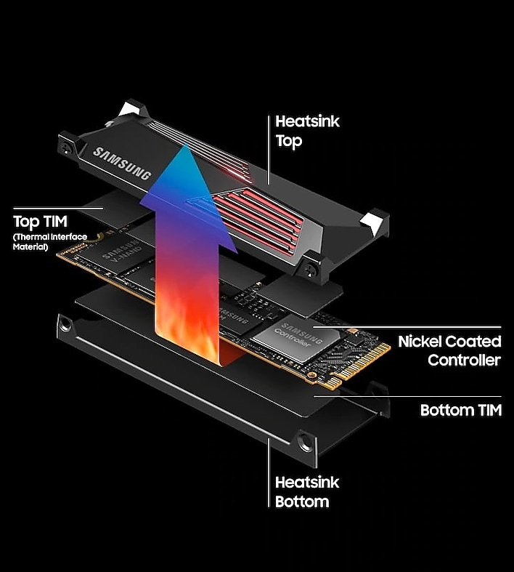

**Made with PS5™ in mind**

Integrated heatsink and PS5 Compatible

Power through all your go-to games and avoid the sudden performance drops. The ultra-slim Integrated Heatsink is designed to dissipate heat from your device to stabilize its temperature and prevent performance issues. It’s compatible with your PlayStation® 5 and PCI-SIG® D8 standard desktops and laptops⁴—so you get uninterrupted play on your favorite platforms.

*⁴ PCI-SIG®D8 standard spec: 8.8mm.*

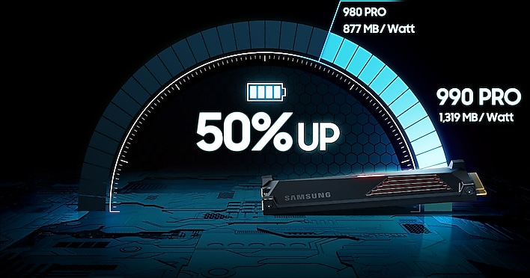

**It's a power move**

Power Efficiency

Save the power for your performance. Get power efficiency all while experiencing up to 50% improved performance per watt over the 980 PRO.⁵ It makes every move more effective with less consumption.

*⁵ 980 PRO Sequential Read/Write - 1,129/877 MB/Watt, 990 PRO Sequential Read/Write - 1380/1319 MB/Watt based on test result of 1TB capacity model.*

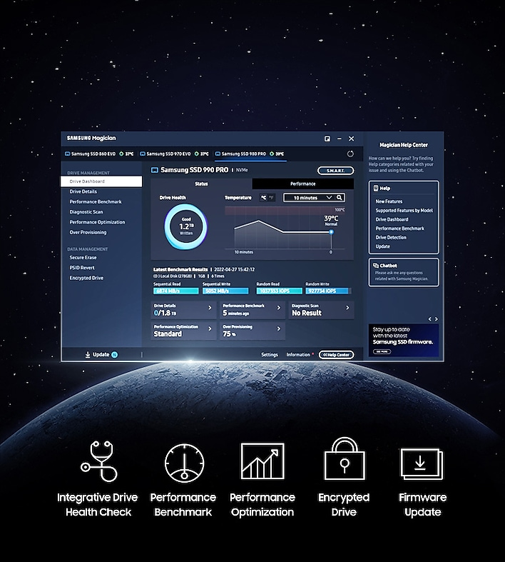

**Unlock the full potential of 990 PRO w/ Heatsink**

Samsung Magician Software

Get the most out of your SSD with Samsung Magician's advanced yet intuitive optimization tools. Monitor drive health, protect valuable data, receive important updates and set up LED color combinations for your 990 PRO with Heatsink. It's your personal SSD toolkit.

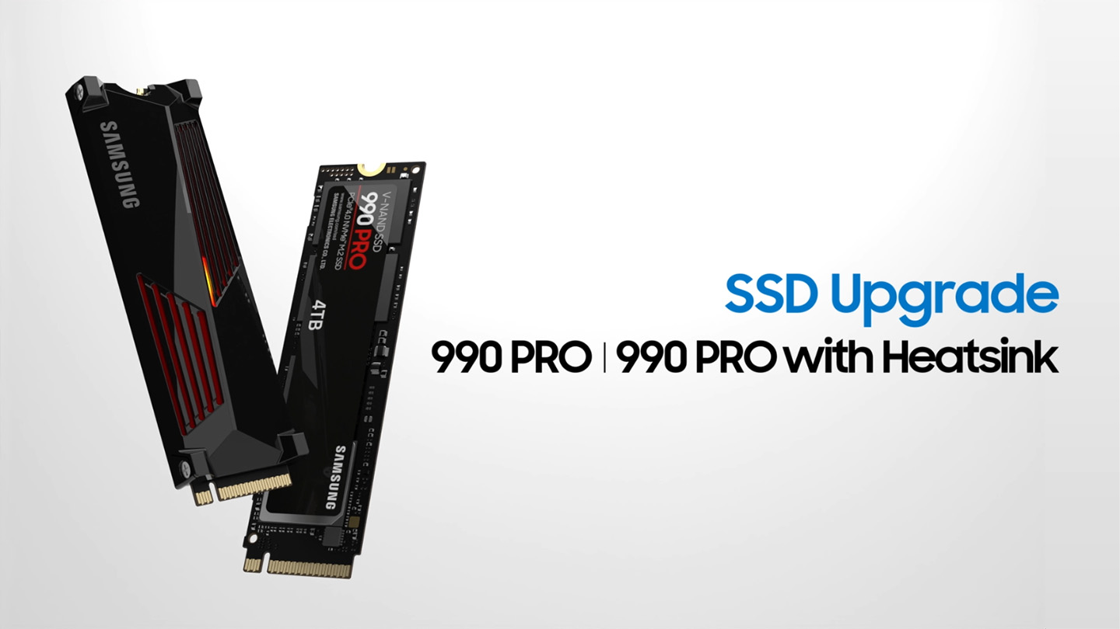

**Unlock the power of Samsung SSDs in a few easy steps**

Follow these simple instructions to install your SSD.